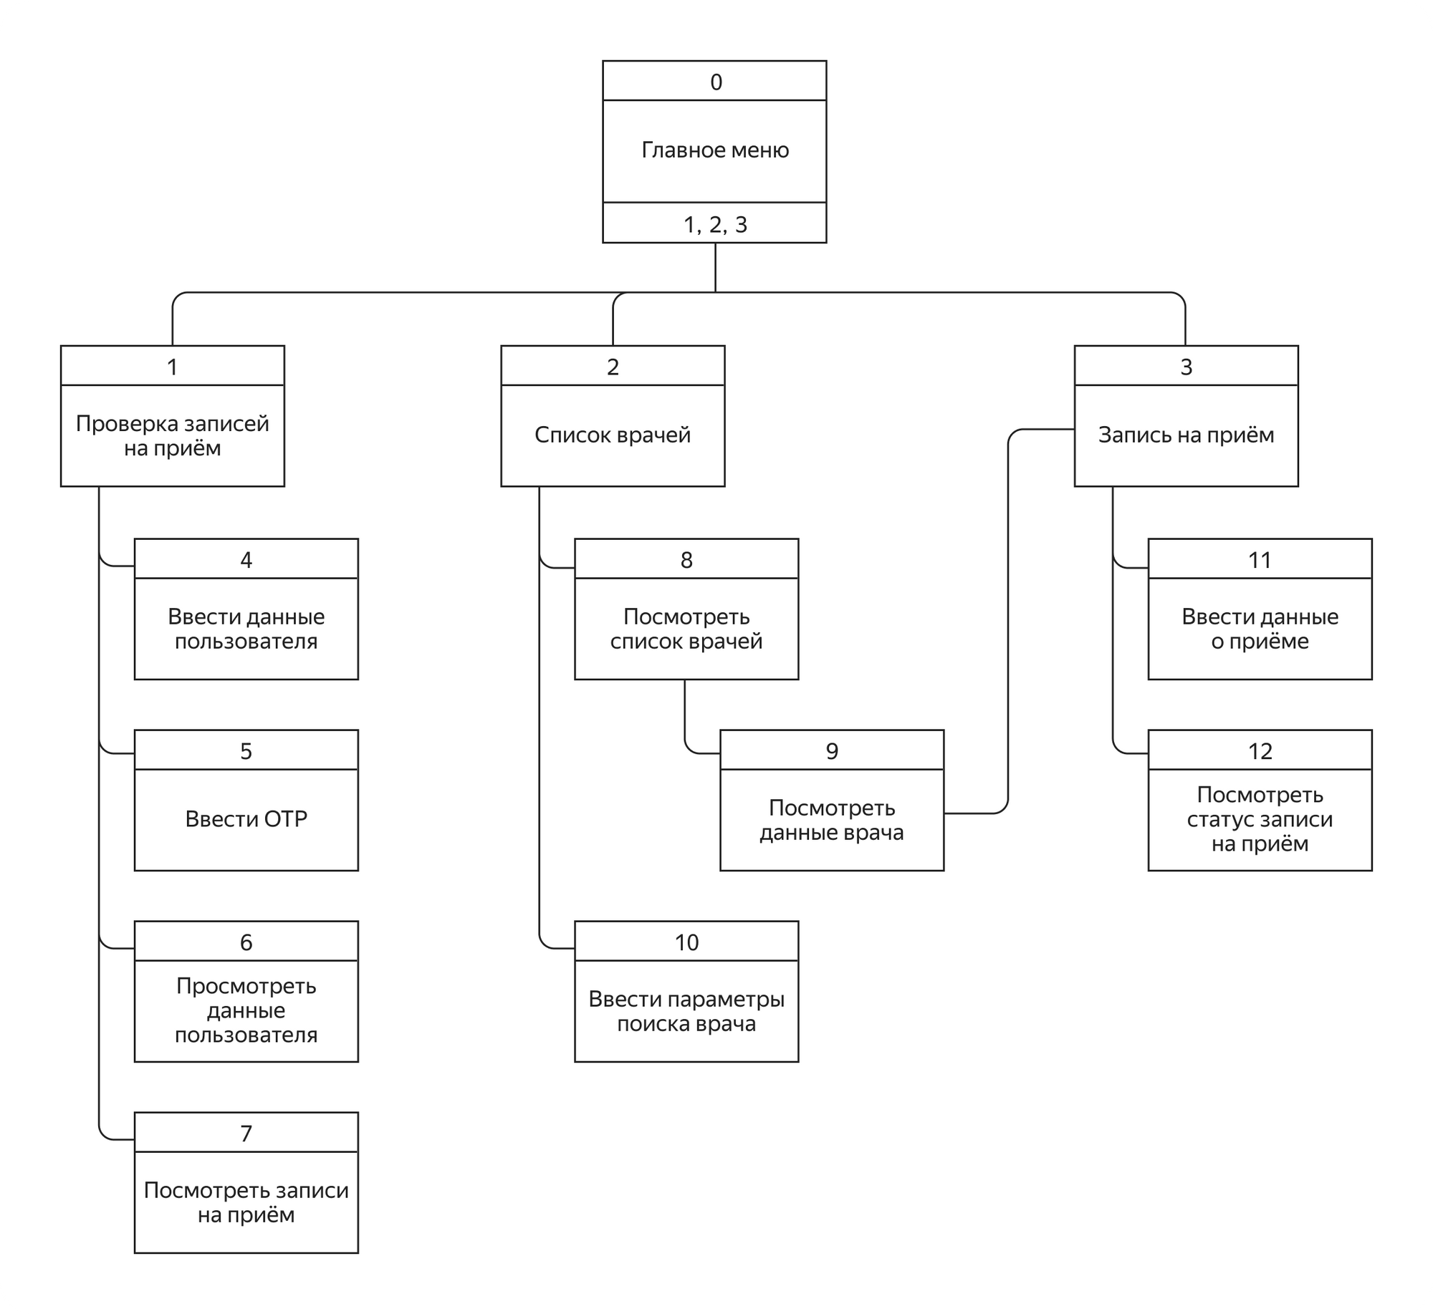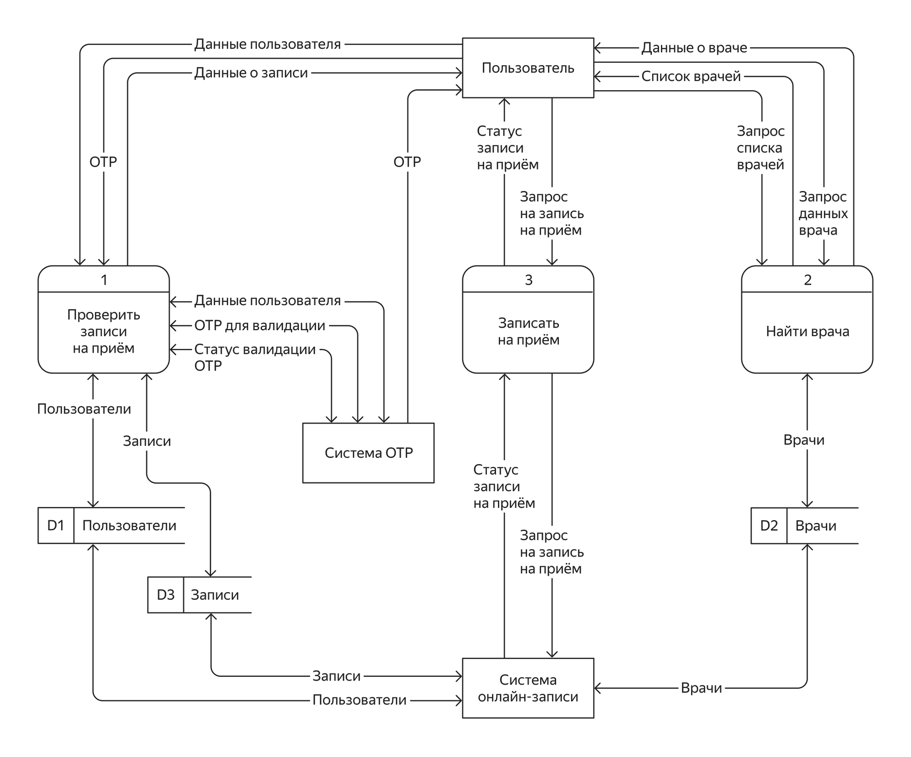

**Ссылка на прототип**

<https://www.figma.com/file/YCHJDKyTuPc8MIRlhP1L20/Storyboard-%D0%BC%D0%BE%D0%B1%D0%B8%D0%BB%D1%8C%D0%BD%D0%BE%D0%B3%D0%BE-%D0%BF%D1%80%D0%B8%D0%BB%D0%BE%D0%B6%D0%B5%D0%BD%D0%B8%D1%8F-%D0%B4%D0%BB%D1%8F-%D1%81%D0%B5%D1%82%D0%B8-%D0%BC%D0%B5%D0%B4%D0%B8%D1%86%D0%B8%D0%BD%D1%81%D0%BA%D0%B8%D1%85-%D0%BA%D0%BB%D0%B8%D0%BD%D0%B8%D0%BA?type=design&node-id=0%3A1&mode=design&t=XgkVRPuKlfHyJ5zr-1>